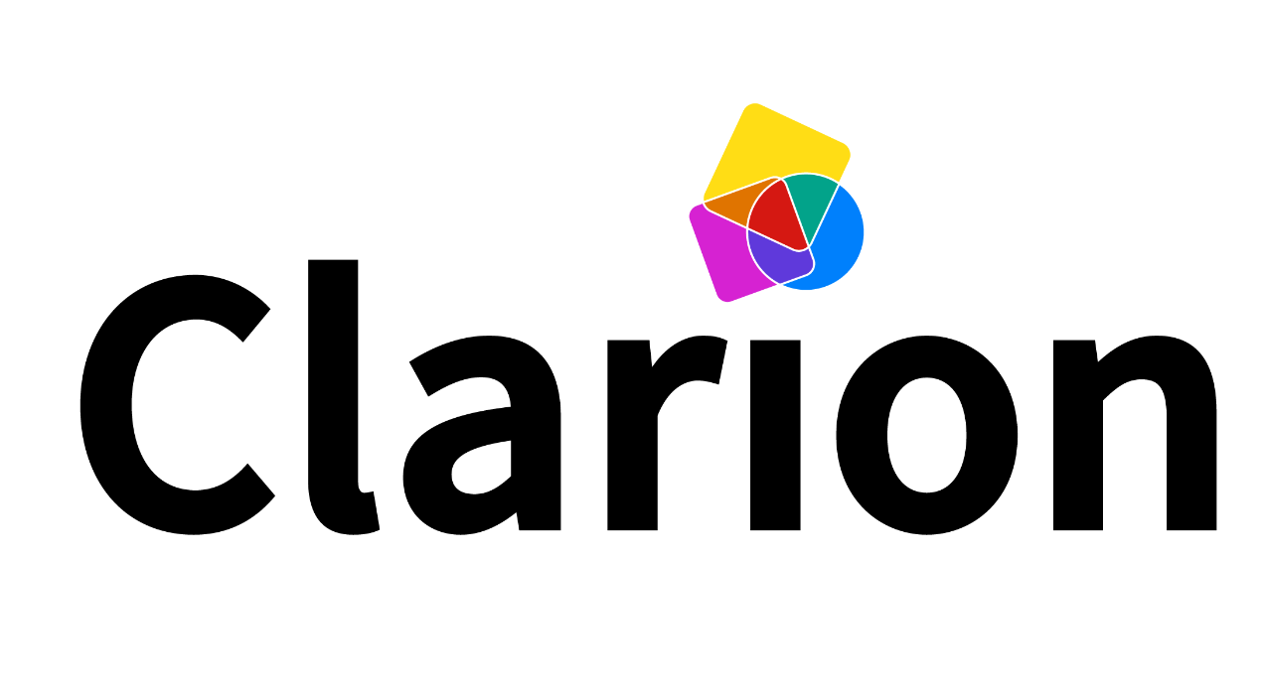
Equipment list

Here is a list of suggested equipment for use with the Clarion. It goes alongside our Essential tips video, which explains how this equipment can be useful. Decide which items you need depending on the needs of musicians, and what equipment you have access to already.

Prices are correct at the time of publishing. Some hyperlinks are Amazon affiliate links - it won’t cost you more to buy, but Amazon will give our charity a small commission from your purchase.

Speakers
Because the built-in speakers on iPads and PCs are not very loud, we strongly recommend connecting the Clarion to its own external loudspeaker. Please note that Bluetooth speakers may cause a noticeable delay between playing notes on the Clarion and actually hearing it.
Minirig 4 | £125.00 | The Minirig is a remarkable, compact speaker. While it may be a bit pricey, it’s worth every penny. With a robust design, intuitive operation and outstanding audio performance, it stands out as our recommended speaker.
Anker Soundcore mini | £23.99 | The Anker is a compact and affordable speaker that features a minimalist design to reduce distractions. Though quieter in volume like the Rienok, it still delivers reasonable sound quality for its low price tag.
Rienok Bluetooth speaker | £18.99 | The Rienok is a budget-friendly speaker that provides reasonably good sound for its price. It is relatively quiet, can produce distracting noises when plugged in or switched on, and its side lights may also be off-putting, yet it remains a reasonable option.
Mini jack to mini jack lead 2 meters | Varies | We recommend connecting the Clarion directly to your speaker using an audio cable instead of using Bluetooth, which causes a noticeable delay between playing notes and hearing the sound. You will need a mini-jack to mini-jack lead for this, and we suggest one that is minimum 2 metres long.

Head control for PC
Musicians can play the Clarion using head movement on PCs, tablets, or laptops using external sensors, allowing for precise head-tracking and motion detection.
Quha Zono | £637.20 | The Quha Zono is an exceptional sensor that can transform music-making for musicians who don’t play with their hands. By simply connecting it to a Windows device, it provides instant mouse control based on head movement, giving the musician complete control over Clarion. We can’t recommend it highly enough!

iPads and iPad accessories
Apple iPad | From £329.00 | Many settings and participants already have iPads, but please check yours are running iOS 13 or higher (this excludes the Apple A7-powered original iPad Air, iPad Mini 2, and iPad Mini 3 models). For consistency, you ideally need the same iPads for each music session, including preparation time beforehand.
Apple USB-C to 3.5 mm Headphone Jack Adapter | £9.00 | Newer iPads no longer have a headphone port, so you will need to buy an adapter to plug them into your speakers.
Manfrotto variable Friction Arm (VFA) iPad mount | £299.00 | Used for positioning iPads in diﬀerent ways for improved player access, this model is a game changer. Cheaper imitations are available but not as robust or versatile (so are a false economy in our opinion.) NB: Double-check that the mount you buy will fit your particular size / type of iPad!
Kensington 'safe-grip' iPad case | £42.00 | Useful for storing, carrying and positioning any iPads. iPads can quickly and easily be taken out of the Kensington case to be mounted on a Variable Friction Arm. NB: Double-check that any case you buy will fit your particular size / type of iPad!

Thank you to Normans Musical Instruments for their support in promoting the Clarion as a classroom instrument, helping to give students the choice of more accessible instruments alongside acoustic ones.

